95702: Distributed Systems  
  
Project 5

Name: Ariane Correa

Andrew ID: ajcorrea

Credentials:   
Login ID: student021

Password: Ar1ane!

Part 1 Task 7 Screenshots:  
  
Task 7 Screenshots:

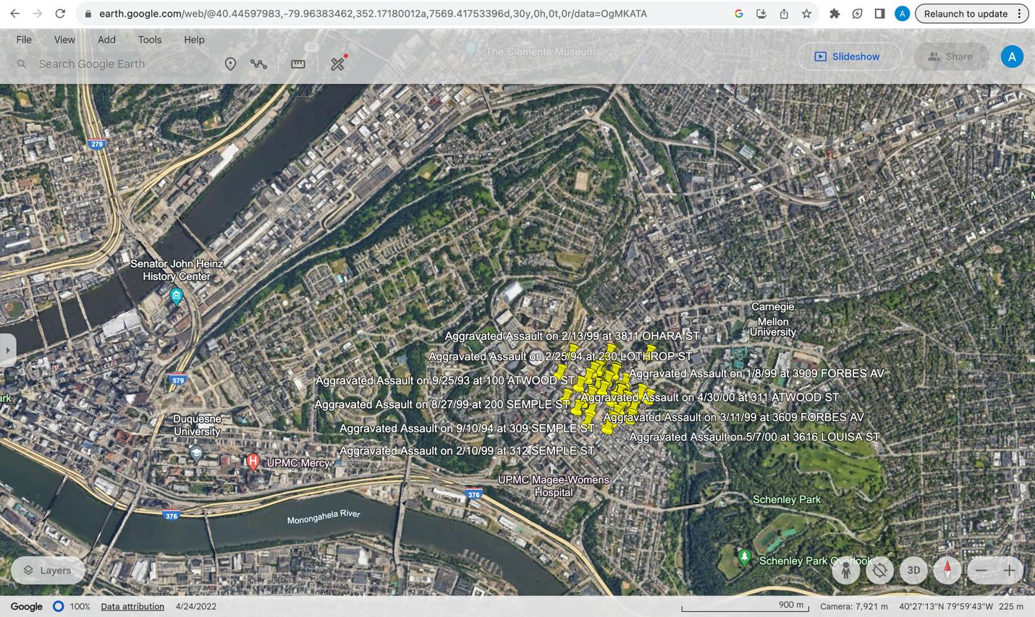

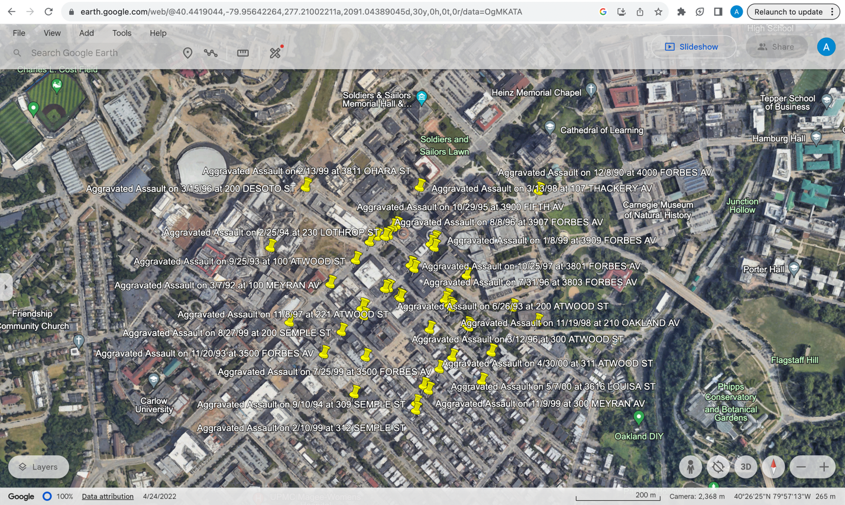

Part 2 Code:

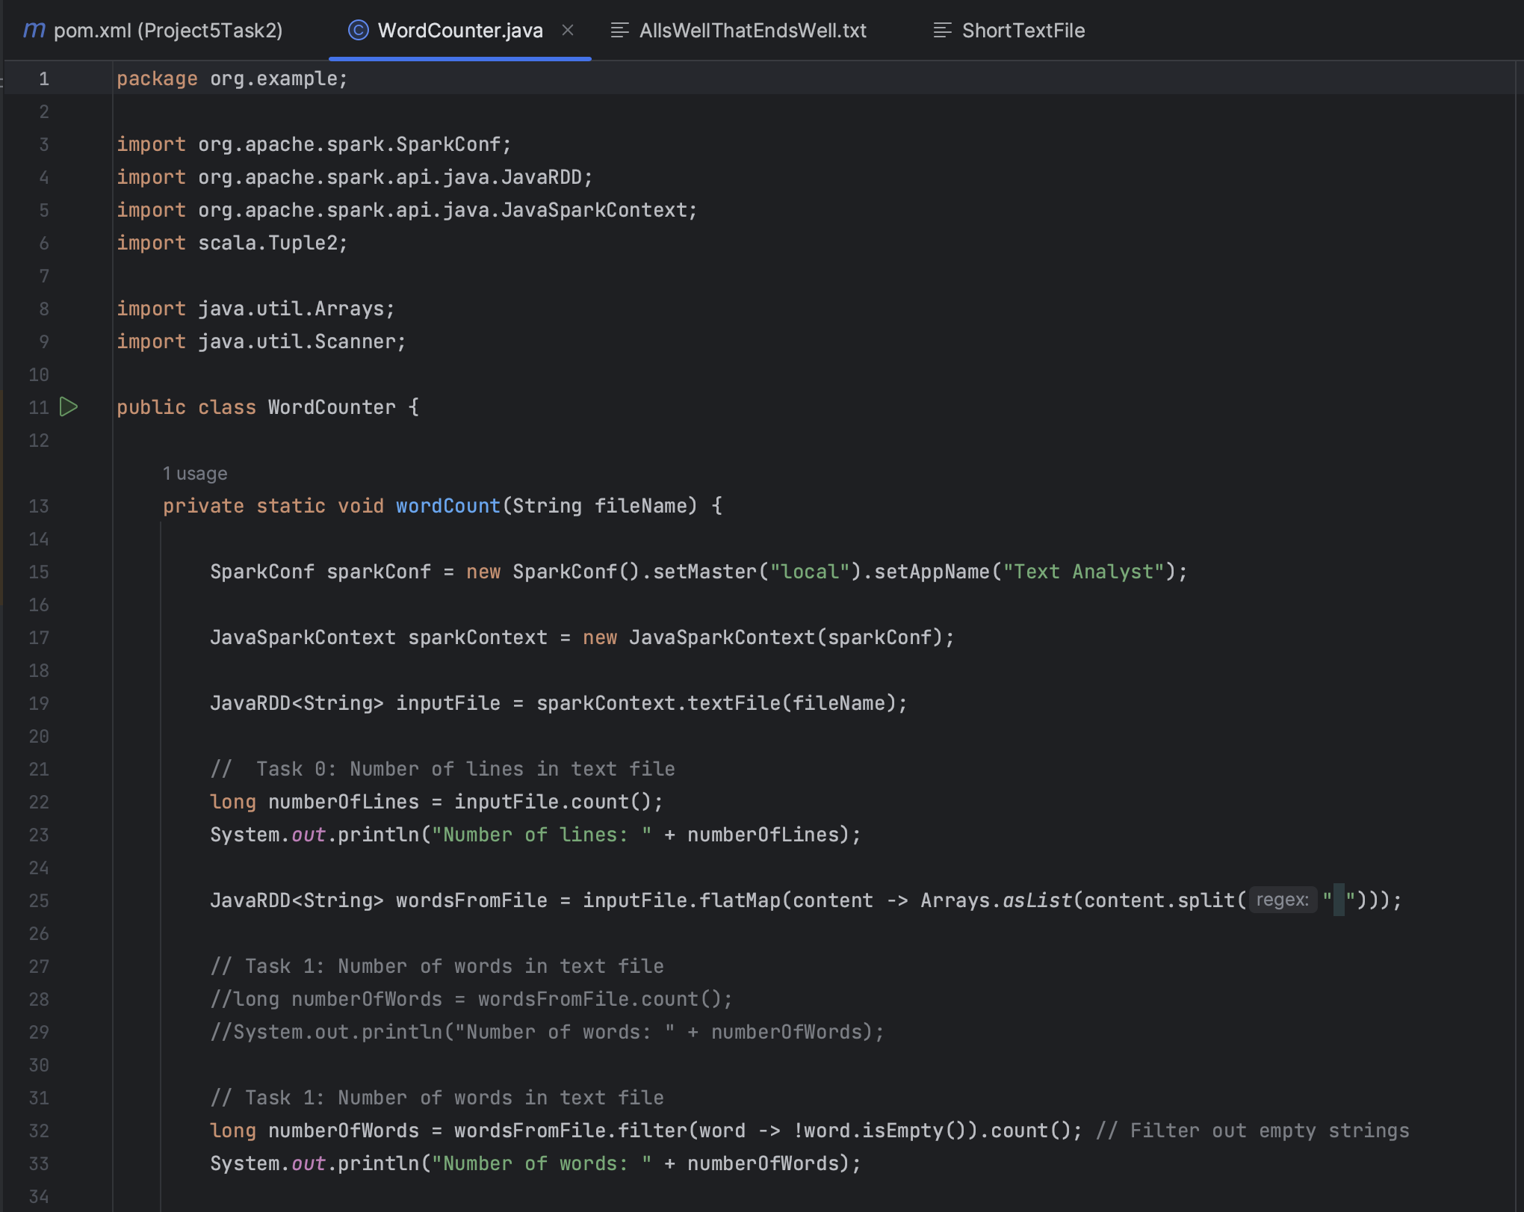

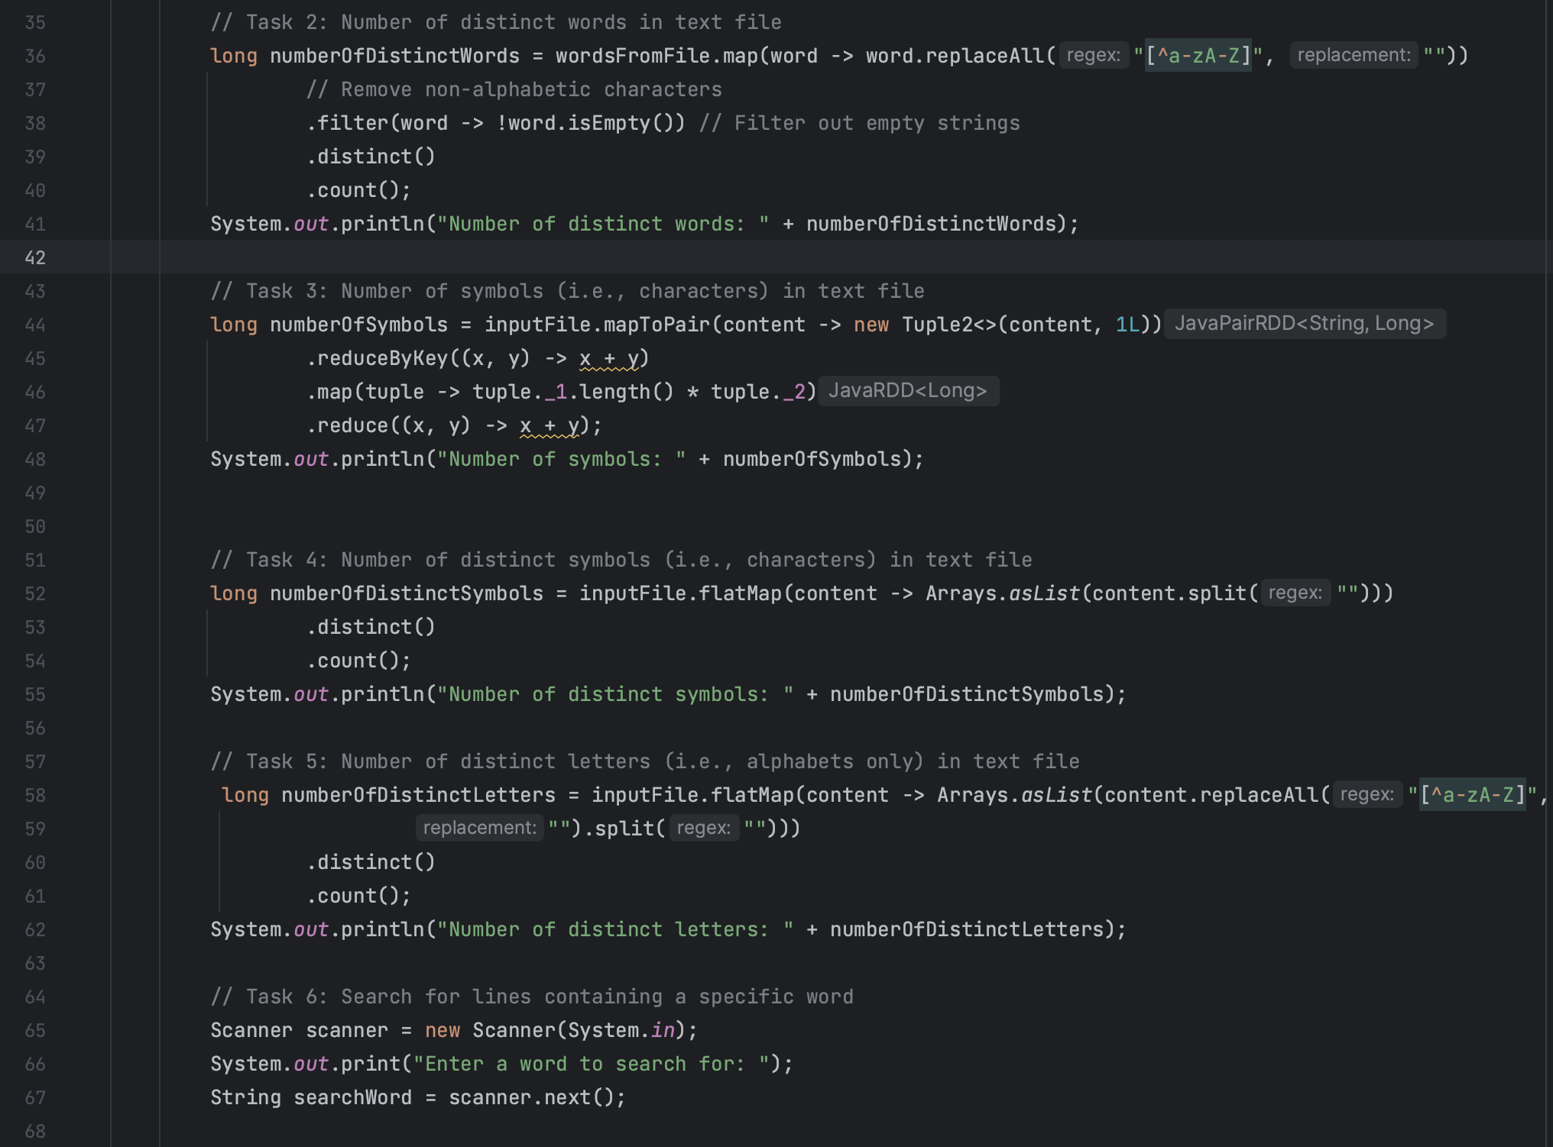

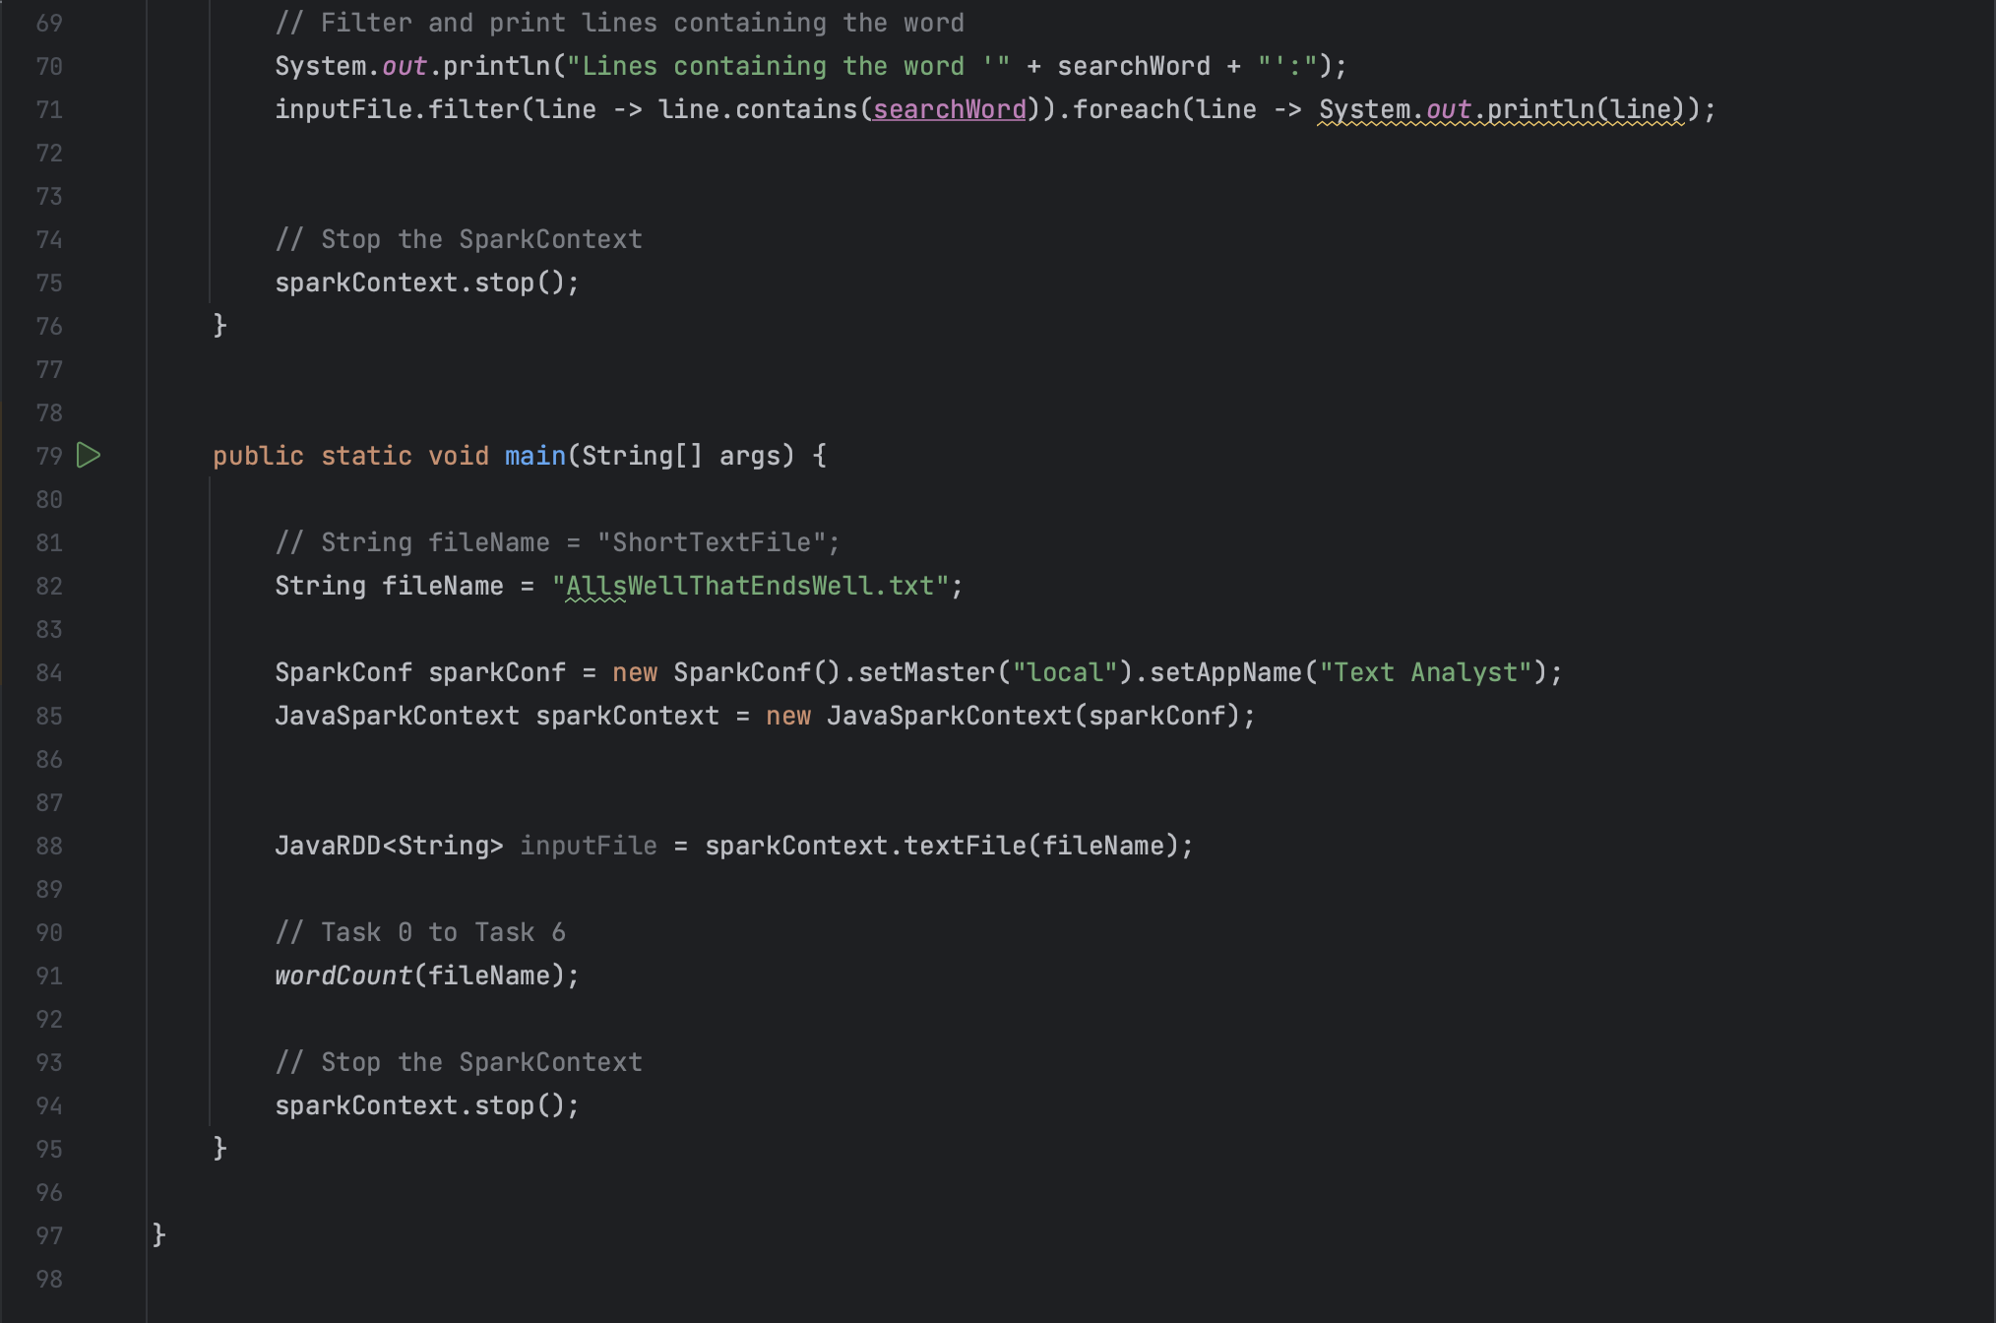

Part 2 Output Screenshots:  
  
Task0:   
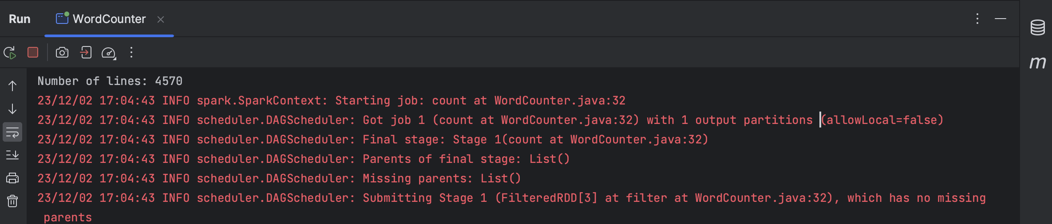  
  
Task1:  
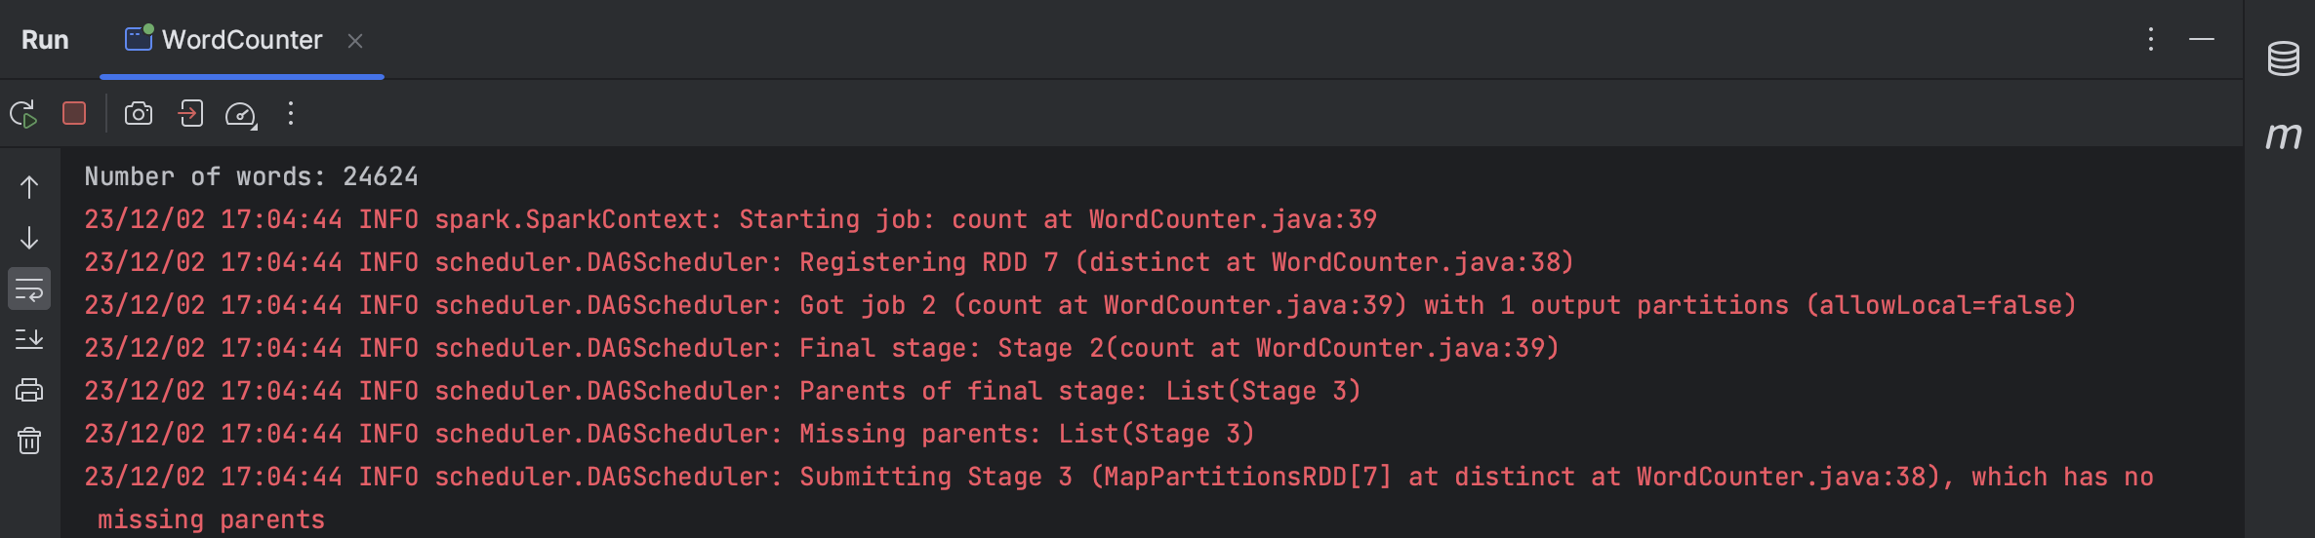

Task2:   
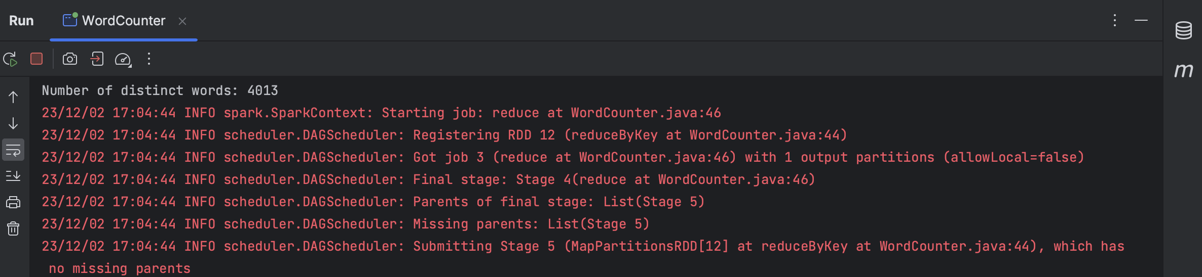

Task3:  
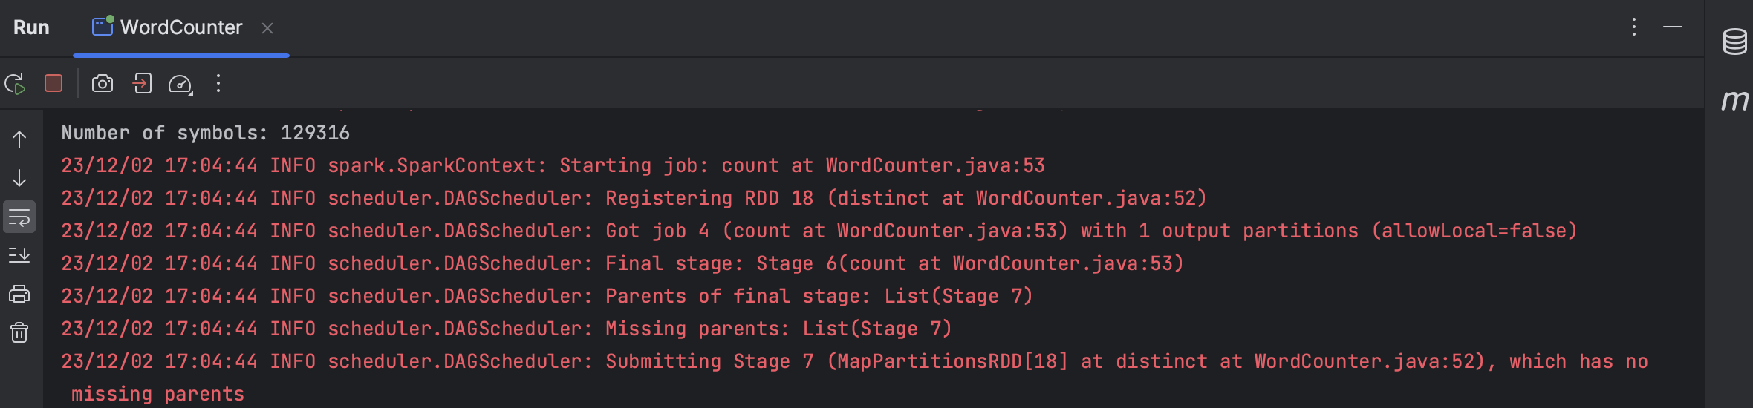  
  
Task4:

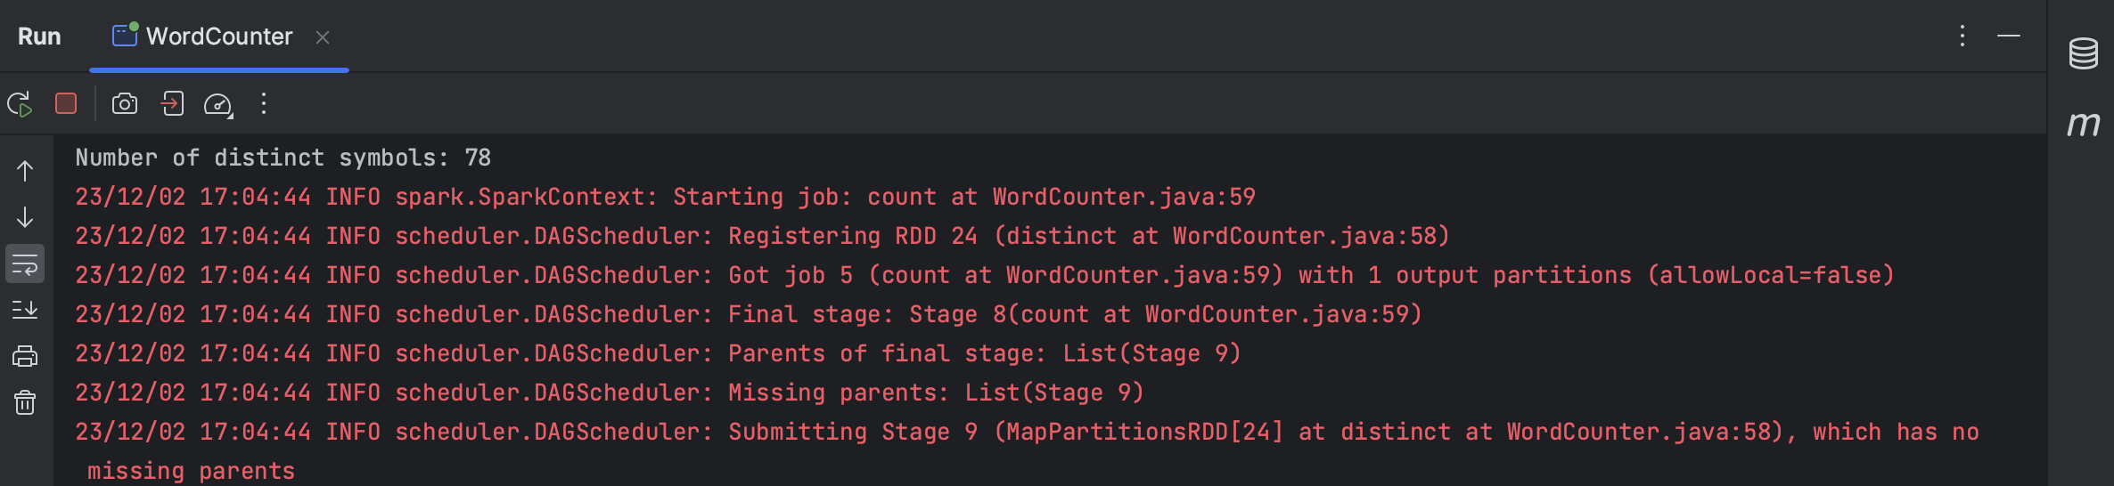  
  
Task5:   


Task6:   
